**VIVEKANAND EDUCATION SOCIETY’S INSTITUTE OF TECHNOLOGY**

Department of Computer Engineering



A Report on

**Image Forgery Analysis and Detection using Image Processing for Forensic Sciences**

**Project Mentor**

Mrs. Sharmilla Sengupta

**Submitted by**

Jaya Kukreja

Hiral Shah

Prajakta Shinde

In partial fulfilment of the Fourth Year (Semester–VIII), Bachelor of Engineering (B.E.) Degree in Computer Engineering at the University of Mumbai for the Academic Year 2013-2014

**VIVEKANAND EDUCATION SOCIETY’S INSTITUTE OF TECHNOLOGY**

Department of Computer Engineering



A Report on

**Image Forgery Analysis and Detection using Image Processing for Forensics Sciences**

**Project Mentor**

Mrs. Sharmila Sengupta

**Submitted by**

Jaya Kukreja (D17-30)

Hiral Shah (D17-53)

Prajakta Shinde (D17-55)

In partial fulfilment of the Fourth Year (Semester–VIII), Bachelor of Engineering (B.E.) Degree in Computer Engineering at the University of Mumbai for the Academic Year 2013-2014

______***29 April, 2014***_______ ___________________________

Date Internal Examiner

|  |  |
| --- | --- |
| __________________________ | ___________________________ |
| Principal | External Examiner |
| (Dr. (Mrs.) J. M. Nair) |  |
|  |  |

**VIVEKANAND EDUCATION SOCIETY’S INSTITUTE OF TECHNOLOGY**



**CERTIFICATE of Approval**

This is to certify that ***___________________________________________________________***of Fourth Year Computer Engineering studying under the University of Mumbai has satisfactorily completed the project on “**Image Forgery Analysis and Detection using Image Processing for Forensics Sciences**”as a part of the coursework of PROJECT-II for Semester-VIII under theguidance of Mrs. Sharmila Sengupta in the year 2013-2014.

______***27 April, 2013***_______ ___________________________

Date Head of the Department

(Dr. (Mrs. Nupur Giri )

____________________________

Project Mentor

(Mrs Sharmila Sengupta)

|  |  |  |
| --- | --- | --- |
| **PEO** | **Outcomes** | **Grade** |
|  |  |  |
| I,II,III,IV | a, b, c, d, e, f, g, h |  |
|  |  |  |

**Acknowledgement**

A Project is creative work of many minds. A Proper synchronization between individual is must for any Project to be completed successfully.

Though words are not enough to express our gratitude to all those who have contributed in making this project, we are grateful to Prof. Dr. Mrs. Nupur Giri, Head of Department of Computer Engineering for making requisite facilities available for us.

We are grateful to Mrs. Sharmila Sengupta, our project mentor, for her valuable guidance with a touch of inspiration and motivation to overcome our way through quite substantial hurdles between plenty of early ideas and finally resulted into the present fine project.

We would also like to thanks the Staff Member of Computer Engineering Department for their constant guidance for the basic logical design.

We are grateful to our Parents & friends for their constant inspiration and Encouragement.

Finally, we would like to express our thanks to all those, who have helped us directly and indirectly.

**Abstract**

Photographs are considered to be the most powerful and trustworthy media of expression. Today, digital images have completely replaced the conventional photographs from every sphere of life but unfortunately, they seldom enjoy the credibility of their conventional counterparts, thanks to the rapid advancements in the field of digital image processing. The increasing availability of low cost and sometimes free of cost image editing software such as Photoshop, Corel Paint Shop, Photoscape, PhotoPlus, GIMP and Pixelmator have made the tampering of digital images even more easier and a common practice. Now it has become quite impossible to say whether a photograph is a genuine camera output or a manipulated version of it just by looking at it. As a result, photographs have almost lost their reliability. This is why digital image tamper detection has emerged as an important research area to establish the authenticity of digital photographs by separating the tampered lots from the original ones. Many forgery techniques are being practiced, such as Splicing, Copy Move, Retouching and Geometrical Transformation. The copy move forgery is one of the most common techniques of image tampering. We have implemented a copy move forgery detection system which uses duplicate region detection based on Singular Value Decomposition (SVD). Also for Splicing, another common technique of image tampering, we have proposed a detection system which is based on Canny Edge Detection. As face recognition is a very valuable aspect of criminal investigation, we have also discussed face recognition using PCA algorithm. Adding on, we have also discussed Double Quantization Effect in JPEG image, which implies that the JPEG image was re-saved after it was opened with a photo editor. We have also discussed Non-consistent image quality for JPEG images, which is every time the JPEG image is re-saved some apparent visual quality is lost and some artifacts appear.

**Table of Contents**

1. **Introduction**
   1. Motivation ....................................................................................................................7
   2. Problem Definition .......................................................................................................7
   3. Relevance of Project ...................................................................................................8
   4. Methodology ................................................................................................................8
2. **Literature Survey**
   1. Role of Images in Forensic Sciences ...........................................................................10
   2. Image Tampering Techniques .....................................................................................11
   3. Forgery Analysis in Forensics .....................................................................................14
   4. Forgery Detection Techniques ....................................................................................16
   5. Feature Extraction .......................................................................................................17
   6. Singular Value Decomposition ...................................................................................19
   7. Principal Component Analysis ....................................................................................20
3. **Requirements**
   1. Functional Requirements ...........................................................................................22
   2. Non-Functional Requirements ...................................................................................22
   3. Constraints ..................................................................................................................22
   4. Hardware and Software Requirements .......................................................................22
   5. Block Diagram ...........................................................................................................23
4. **Proposed Design**
   1. Flowchart ....................................................................................................................26
   2. Plan of Work ..............................................................................................................29
   3. Project Scheduling .....................................................................................................29
5. **Implementation**
   1. Copy Move Forgery ...................................................................................................30
   2. Recognition ................................................................................................................32
   3. Deletion of an Object .................................................................................................33
   4. Splicing ......................................................................................................................35
   5. Double Quantization Effect ........................................................................................38
   6. Steganalysis ................................................................................................................40
   7. Non-Consistent Image Quality ...................................................................................41
6. **Result Analysis**
   1. Parameter ....................................................................................................................43
   2. Graphs ........................................................................................................................44
   3. Output .........................................................................................................................47
7. **Conclusion**
   1. Limitation ...................................................................................................................54
   2. Conclusion ..................................................................................................................54
   3. Future Work ...............................................................................................................54
8. **References** .....................................................................................................................55
9. **List of Figures** ..............................................................................................................57
10. **List of Tables** ..........................................................................................................60
11. **Paper Published** ....................................................................................................61

**Chapter 1: INTRODUCTION**

* 1. **Motivation**

In this digital world we come across many image processing software that produce doctored Images with high sophistication, which are manipulated in such a way that the tampering is not easily visible to naked eye. The authenticity of a digital image has become a challenging task due to the various tools present in the photo editing software packages.

With the rapid development of image processing technology, it is getting easier to tamper with digital images without leaving any obvious visual trace. Today, seeing is no longer believing. Image forgery, like any other illegal and pernicious activity, could cause serious harm to society. Therefore, verifying the authenticity of digital images has become a very important issue.

This availability brought with it new challenges concerning the integrity and authenticity of digital documents, in particular images. Digital cameras and photo- editing software packages are used to create and edit digital images easily and manipulated without leaving any obvious traces of having been modified.

* 1. **Problem Definition**

Images play an important role in forensics laboratory. With the ease of using image-processing tools, non-existing situations can be created and presented as evidence in a court of law. This diminishes the credibility of photographs as a definitive proof of events. As it is simple to manipulate and modify digital images without leaving any obvious traces of tampering. For digital image to be used as evidence, image authentication is necessary. Digital image forensics is used for authenticating information available in images. This project encompasses analysis of possible image forgeries and implementation of detection techniques for some of the forgeries.

Implementation involves:

* Recognition
* Splicing
* Steganalysis
* Copy-move forgery detection
* Detection of deletion of an object
  1. **Relevance of the project**

Images have long been a part of forensic studies and law enforcement; for example images of criminals, images of crime scenes, biometric images, etc. Images play a vital role in the forensic laboratory, as images are used to document crime scene evidence. When these images are produced as evidences in courtrooms, integrity of images is very important. Images are used as authenticated proof for any crime and if these image does not remain genuine than it will create a problem. Most of the applications that use digital images are sensitive applications; like a judgment made in a courtroom based on an image produced as evidence, etc.

The increasing availability of low cost and sometimes free of cost image editing has made the tampering of digital images even easier and a common practice. As a result, photographs have almost lost their reliability and place as proves of evidences in all fields. This is why digital image tamper detection has emerged as an important research area to establish the authenticity of digital photographs by separating the tampered lots from the original ones.

Digital image forensics is used for:

* Authentication of images captured from CCD (charge coupled device) cameras
* Authentication of information available in an image
* Authenticity of evidences
* Fingerprint recognition
* Document authentication
  1. **Methodology used**

The set of image forensic tools can be roughly grouped into five categories, Pixel-based, format-based, camera-based, physically-based, and geometric-based. We have used pixel based techniques for forgery detection. In the digital domain, the emphasis is on the pixel – the underlying building block of a digital image. Pixel-based techniques analyze the correlation between pixels either directly in the spatial domain or in some transformed domain. They detect statistical anomalies introduced at the pixel level. Four techniques for detecting various form of tampering, each of which directly or indirectly analyzes pixel-level correlations that arise from a speciﬁc form of tampering: Cloning, Re-sampling, Splicing and Statistical.

The two most commonly used approaches for Image forgery Detection are block-based detection techniques and feature based detection techniques. Block based techniques predominantly deals with pixel based image comparison (taking small blocks of pixels at a time). Whereas feature based techniques use features of an image for their comparison instead of blocks. Feature based technique is transform invariant, that is if appropriate features are selected, invariance to a number of transformations can be achieved.

Block-based processing is a popular technique used in image processing where the image is broken into sub-parts or equal squares. Each block is considered as a sub-image. This method is allows recursive type processing, with the sub-processing resembling a “divide and conquer” approach. Block-based processing is useful because the calculations performed are influenced by only the information present in that particular block.

**Chapter 2: LITERATURE SURVEY**

* 1. **Role of images in forensic sciences**

Digital Photo images are everywhere, on the covers of magazines, in newspapers, in courtrooms, and all over the Internet. Digital Images have an essential role in many areas, including: forensic investigation, criminal investigation, surveillance systems, intelligence services, medical imaging, and journalism. We are exposed to them throughout the day and most of the time. Ease with which images can be manipulated; we need to be aware that seeing does not always imply believing. The use of digital photography has increased over the past few years, a trend which opens the door for new and creative ways to forge images. Now a day’s several software’s are available that are used to manipulate image so that the image is look like as original. Detecting these types of forgeries has become serious problem at present. To determine whether a digital image is original or doctored is a big challenge. To find the marks of tampering in a digital image is a challenging task.

Images have long been a part of forensic studies and law enforcement; for example images of criminals, images of crime scenes, biometric images, etc. Images play a vital role in the forensic laboratory, as images are used to document crime scene evidence. When these images are produced as evidences in courtrooms, integrity of images is very important. Images are used as authenticated proof for any crime and if these image does not remain genuine than it will create a problem. Most of the applications that use digital images are sensitive applications; like a judgment made in a courtroom based on an image produced as evidence, etc.

For digital photographs to be used as evidence in law issues or to be circulated in mass media, it is inevitably needed to identify whether an image is authentic or not. The ease of creating faked digital images with a realistic quality makes us think twice before accepting an image as authentic. For the news photographs and the electronic check clearing systems, image authenticity becomes extremely critical. The verification of originality of images is required in variety of applications such as military, forensic, media, scientific, glamour, etc. Digital Image Forensics deals with the problem of certifying the authenticity of a picture, or its origin, without explicit a priori information, e.g. using watermarks. There are the three main branches in this research field: image source identification; discrimination of computer generated images; image forgery detection. In this paper we focused with the problem of detecting image forgeries.

* 1. **Image Tampering Techniques[2]**
* Splicing:

It is a method of tampering images by combining two sources to produce a new image which retains the majority of one image for detail.

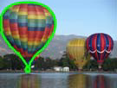

Fig1: (a) Source image



Fig1: (b)Target image



Fig1: (c) Spliced image

* Retouching:

Retouching is used for photo enhancement i.e. enhancing the appeal of the image by adjusting colors / contrast / white balance (i.e. gradational retouching), sharpness, removing elements or visible flaws on skin or materials, etc. Retouching is mostly done for magazine covers, photo shoots to give a better feel to the photo.

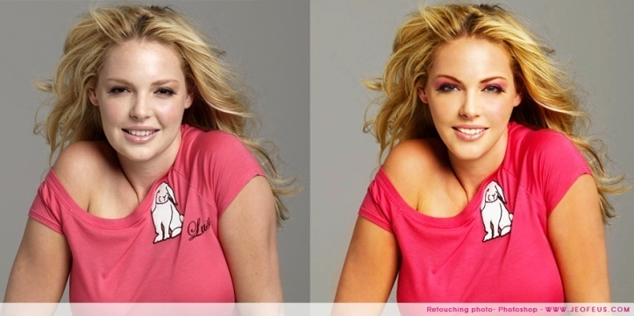

Fig2: Before and after retouching image

* Copy-Move Attack:

A copy move attack is commonly used to conceal parts of an image or to remove unwanted portions in an image. A portion from the picture is copied and pasted over any unwanted portion in the same image. It is also called as cloning.

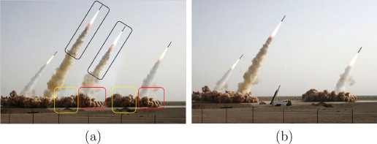

Fig3: After and before copy move attack

* Morphing:

Morphing is a [special effect](/wiki/Special_effect) in [motion pictures](/wiki/Film) and [animations](/wiki/Animation) that changes (or morphs) one [image](/wiki/Image) into another through a seamless transition. Most often it is used to depict one person [turning into another](/wiki/Shapeshifting) through technological means or as part of a fantasy or surreal sequence. Traditionally such a depiction would be achieved through cross-fading techniques on film. Since the early 1990s, this has been replaced by computer software to create more realistic transitions.

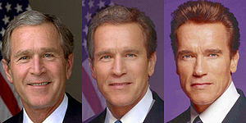

Fig4: Middle image is the morphed image

* Geometrical transformation:

Some images have a portion of the picture altered by some common geometric transformations such as translation, scaling and rotation. Forgers make a copy of the portion of the picture; make changes to it by geometrically modifying that portion of the image.



Fig5: (a) Original Image of evidence showing a cartridge



Fig5: (b) Fake Image of evidence showing two cartridges;

Second, scaled and transformed

* Steganography

Steganography is the science that involves communicating secret data in an appropriate multimedia carrier, e.g., image, audio, and video files. It comes under the assumption that if the feature is visible, the point of attack is evident, thus the goal here is always to conceal the very existence of the embedded data.

Image Steganography is the process of secret communication where a piece of information (a secret message or an image, preferably encrypted) is encoded into the bits of an innocent looking cover image, in such a manner that the very existence of the secret information remains concealed without raising any suspicion in the minds of the viewers. Because of its inherent purpose of data hiding, Steganography requires the original and the Stego image to look alike. Steganography is more global in nature and offer vary little or no change to the image content in comparison to tampering which makes dramatic changes to the image content those are more local in nature.

Fig6: (a) Original image, (b) Image to be hidden, (c) Output image

* 1. **Forgery Analysis in Forensics**

1. ***Questioned Documents:*** [crime scene investigation](http://science.howstuffworks.com/csi.htm), [DNA testing](http://science.howstuffworks.com/dna-evidence.htm), fiber analysis, fingerprint analysis, voice identification and narcotics analysis, handwriting analysis. **Detection of forged documents involves writing and media. This includes papers, inks, pencil etc.**
2. ***Art Forgery:*** It is the creating and selling of works of [art](http://en.wikipedia.org/wiki/Art) which are falsely credited to other, usually more famous, artists.
3. ***Image Forgery[1][2]:***

* **Copy-Move Forgery:**

**Images tampered by copying one area in an image and pasting it onto another area. It is called as Copy-Move Forgery or Cloning. This forgery is copying and pasting areas from one or more images and pasting on to an image being forged.** Copy-Move is a specific type of image manipulation, where a part of the image itself is copied and pasted into another part of the same image.

* **JPEG Format Analysis:**

The JPEG Format Analysis algorithm makes use of information stored in the many technical meta-tags available in the beginning of each JPEG file. These tags contain information about quantization matrixes, Huffman code tables, and many other parameters as well as a miniature version (thumbnail) of the full image.

* **Double Quantization Effect:**

When altering a JPEG image, typically it is loaded into photo–editing software (decompressed) and after manipulations is carried out; the image is re–saved (compressed again). The quantization matrix of the unaltered image is called as primary quantization matrix. The quantization matrix of the re–saved image is called as secondary quantization matrix. If the primary and secondary quantization matrix are not identical, then the re–saving (double compressing) operation brings into the image specific changes.

* **Error Level Analysis:**

It detects foreign objects injected into the original image by analyzing quantization tables of blocks of pixels across the image. Quantization of certain pasted objects (as well as objects drawn in an editor) may differ significantly from other parts of the image, especially if either (or both) the original image or injected objects were previously compressed in JPEG format.

* **Non-consistent Image Quality:**

JPEG is a lossy format. Every time the same image is opened and saved in the JPEG format, some apparent visual quality is lost and some artifacts appear. You can easily reproduce the issue by opening a JPEG file, saving it, closing, then opening and saving again. Repeat several times, and you’ll start noticing the difference; sooner if higher compression levels are specified.

* **Mixed Images:**

Images generated by Splicing, Steganoqraphy and, Scaling and Tilting. Splicing is copying and pasting areas from one or more images and pasting on to an image being forged. Image Steganography is the process of secret communication where a piece of information (a secret message or an image, preferably encrypted) is encoded into the bits of an innocent looking cover image, in such a manner that the very existence of the secret information remains concealed without raising any suspicion in the minds of the viewers. Scaling and Tilting is copying an object and applying geometrical transform on it.

* 1. **Forgery Detection Techniques[2][3]**

Digital image forgery detection techniques are classified into active and passive approaches. In active approach, the digital image requires some pre-processing such as watermark embedding or signature generation at the time of creating the image, which would limit their application in practice. Active methods work only when we have some prior information about the image. Moreover, there are millions of digital images in internet without digital signature or watermark. In such scenario active approach could not be used to find the authentication of the image. Hence such a method does not work when handling images from unknown or unreliable sources.

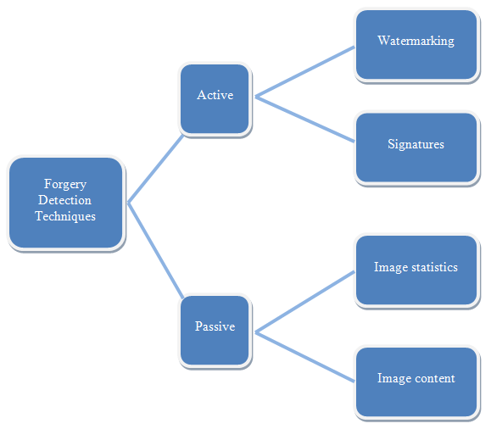

Fig7: Classification of Forgery detection techniques

Unlike the watermark-based and signature-based methods; the passive technology does not need any digital signature generated or watermark embedded in advance. These techniques work on the assumption that although digital forgeries may leave no visual clues that indicate tampering, they may alter the underlying statistics of an image. There is a very low probability that images used in forensics like crime scene images, photographs of criminals, fingerprint images etc will be secured by digital watermarks or digital signatures. Hence, Passive/ Blind techniques are the best approach to detect tampering in images used by the forensic department because a passive method does not require any prior information about the image. To detect the traces of tampering, blind methods use the image function and the fact that forgeries can bring into the image specific detectable changes.

The set of image forensic tools can be roughly grouped into five categories:

* Pixel-based techniques: detect statistical anomalies introduced at pixel level.
* Format-based techniques: leverage statistical correlations introduced by specific lossy compression scheme.
* Camera based techniques: exploit artifacts introduced by camera lens , sensor or on-chip post-processing.
* Physically based techniques: explicitly model and detect anomalies in three dimensional interactions between physical objects, light and camera.
* Geometric based techniques: make measurements of objects in the world and their positions relative to camera.
  1. **Feature Extraction**

In [pattern recognition](http://en.wikipedia.org/wiki/Pattern_recognition) and in [image processing](http://en.wikipedia.org/wiki/Image_processing), feature extraction is a special form of reduction. When the input data to an [algorithm](http://en.wikipedia.org/wiki/Algorithm) is too large to be processed and it is suspected to be notoriously redundant (e.g. the same measurement in both feet and meters) then the input data will be transformed into a reduced representation set of features (also named features vector). Transforming the input data into the set of features is called feature extraction. If the features extracted are carefully chosen it is expected that the features set will extract the relevant information from the input data in order to perform the desired task using this reduced representation instead of the full size input.

Feature extraction involves simplifying the amount of resources required to describe a large set of data accurately. When performing analysis of complex data one of the major problems stems from the number of variables involved. Analysis with a large number of variables generally requires a large amount of memory and computation power or a [classification](http://en.wikipedia.org/wiki/Statistical_classification) algorithm which overfits the training sample and generalizes poorly to new samples. Feature extraction is a general term for methods of constructing combinations of the variables to get around these problems while still describing the data with sufficient accuracy

It can be used in the area of image processing which involves using algorithms to detect and isolate various desired portions or shapes (features) of a digitized image or video stream. It is particularly important in the area of optical character recognition.

Feature extraction a type of dimensionality reduction that efficiently represents interesting parts of an image as a compact feature vector. This approach is useful when image sizes are large and a reduced feature representation is required to quickly complete tasks such as image matching and retrieval. Feature detection, feature extraction, and matching are often combined to solve common computer vision problems such as [object detection](http://www.mathworks.in/products/computer-vision/description4.html) and [recognition](http://www.mathworks.in/discovery/object-recognition.html), content-based image retrieval, face detection and [recognition](http://www.mathworks.in/discovery/face-recognition.html), and texture classification.

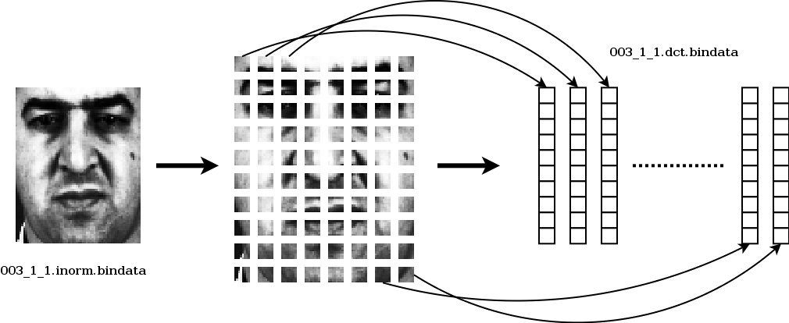

Fig8: Feature Extraction

There have been several kinds of features to be used for the purpose of feature extraction in images, they are as follows:

1. Visual features;
2. Statistical features of pixel;
3. Transform coefficient features
4. Algebraic features

Common feature extraction techniques include:

* Principal Component Analysis (PCA)
* Discrete Cosine Transform (DCT)
* Discrete Wavelet Transform (DWT)
* Fourier Mellin Transform (FMT)
* Singular Values (SV)
* Scale Invariant Features Transform (SIFT)
* Speed up Robust Features (SURF)
* Independent Component Analysis and so on
  1. **Singular Value Decomposition (SVD)[11]**

The singular value decomposition (SVD) is a [factorization](http://en.wikipedia.org/wiki/Matrix_decomposition) of  [real](http://en.wikipedia.org/wiki/Real_number) or [complex](http://en.wikipedia.org/wiki/Complex_number) [matrix](http://en.wikipedia.org/wiki/Matrix_(mathematics)), with many useful applications in [signal processing](http://en.wikipedia.org/wiki/Signal_processing), data compression, pattern analysis and statistics.

SVD is a matrix factorization and has 3 properties stability, scaling and rotation invariance which represent algebraic and geometric invariant properties of an image.. The singular values are unique for a matrix, which is a steady representation of image blocks

Formally, the singular value decomposition of an m×n real or complex matrix M is a factorization of the form  where U is a m×m real or complex [unitary matrix](http://en.wikipedia.org/wiki/Unitary_matrix), Σ is an m×n [rectangular diagonal matrix](http://en.wikipedia.org/wiki/Rectangular_diagonal_matrix) with nonnegative real numbers on the diagonal, and V* (the [conjugate transpose](http://en.wikipedia.org/wiki/Conjugate_transpose) of V, or simply the transpose of V if V is real) is an n×n real or complex [unitary matrix](http://en.wikipedia.org/wiki/Unitary_matrix). The diagonal entries Σi,i of Σ are known as the [singular values](http://en.wikipedia.org/wiki/Singular_value) of M. The m columns of U and the n columns of V are called the left-singular vectors and right-singular vectors of M, respectively.

The singular value decomposition and the [eigendecomposition](http://en.wikipedia.org/wiki/Eigendecomposition) are closely related. Namely:

* The left-singular vectors of M are [eigenvectors](http://en.wikipedia.org/wiki/Eigenvectors) of MM*.
* The right-singular vectors of M are eigenvectors of M*M.
* The non-zero singular values of M (found on the diagonal entries of Σ) are the square roots of the non-zero [eigenvalues](http://en.wikipedia.org/wiki/Eigenvalues) of both M*M and MM*.

Applications which employ the SVD include computing the [pseudoinverse](http://en.wikipedia.org/wiki/Moore%E2%80%93Penrose_pseudoinverse), [least squares](http://en.wikipedia.org/wiki/Least_squares) fitting of data, matrix approximation, and determining the [rank](http://en.wikipedia.org/wiki/Rank_of_a_matrix), [range](http://en.wikipedia.org/wiki/Range_of_a_matrix) and [null space](http://en.wikipedia.org/wiki/Kernel_(matrix)) of a matrix.

* 1. **Principal component Analysis (PCA)[13][14][15]**

PCA is one of the most important techniques in image recognition and feature extraction. Loosely speaking, the idea of the principal component analysis is to reduce the dimension of a data set where one has great number of non necessary independent variables, and to retain as much as possible the variations of the data set. If we imagine that each measurement type corresponds to an axis in a *d* dimensional space (that is, we have *d* different types of characteristics), the idea of PCA is to reduce this dimension by considering a new basis obtained by some orthogonal transformation.

In PCA and all its variants the method follows the schema: by some considerations one constructs a covariance matrix, symmetric, that is with real eigenvalues and diagonalizable by some orthogonal transformation given by its eigenvectors. These eigenvectors, corresponding to ordered eigenvalues, represent the principal directions and that linear combination of the characteristics mentioned above.

**Classical PCA**

Let *A* be an *m× n* image, considered as a random matrix.In the classical PCA approach this matrix is reshaped into a vector of dimension *mn ×* 1, by concatenating its columns. The associated scatter (covariance) matrix is computed by $$S^{1D}=\frac{1}{M}\sum_{j=1}^{M}{\left[a_{j}-\overline{a}\right]{[a_{j}-\overline{a}]}^{T}}$$

This is a *mn × mn* matrix. *M* denotes the number of training images in the database. The principal directions are the ordered eigenvectors of this matrix. Each of the *M* reshaped images is projected on a certain number of principal directions.

**Two Dimensional PCA (2DPCA) & Two Dimensional Two Directional PCA (2D2DPCA)**

The covariance matrix is computed directly from the 2D image which means that the covariance matrix and the eigenvectors have smaller dimension. The scatter matrix for 2DPCA is given by:

$$S^{2D}=\frac{1}{M}\sum_{j=1}^{M}{\left[A_{j}-\overline{A}\right]{[A_{j}-\overline{A}]}^{T}}$$

In this case we perform a 2DPCA by working on the columns of the images.2DPCA can be performed on columns and rows as well. The 2D2DPCA method combines the row and column approaches of 2DPCA.

Other variants of PCA are:

* Extended Two Dimensional PCA (E2DPCA)
* Extended Two Dimensional Two Directional PCA (E2D2DPCA)

In PCA the covariance matrix has large dimension therefore the computation of eigenvectors is time consuming and the results are not always satisfactory. Thus different variants of PCA are used for accuracy and speed and less memory requirement.

**Chapter 3: REQUIREMENTS**

* 1. **Functional Requirements**
* Project should be able to analyze image for presence of different types of forgeries.
* It should be able to recognize which type of forgery is present in the image.
* It should be able to detect the forged part of the image if the image is forged.
* It should also be able to detect if any other data is hidden in the image using Steganography.
* If any other data is hidden, it should be able to retrieve that data from the image.
  1. **Non-Functional Requirements**
* Project should have low false positive.
* Project should have low false negative.
  1. **Constraints**
* Confidential data.
* CBI data is confidential and hence cannot be used by us.
* Hence data used in this project is sample data taken by us and it is solely dependent on research work.
* Image used for Steganography should not be in JPEG format as it is lossy.
  1. **Hardware & Software Requirements**
* Computer with Windows operating system installed.
* Matlab R2010a installed.
  1. **Block Diagram**

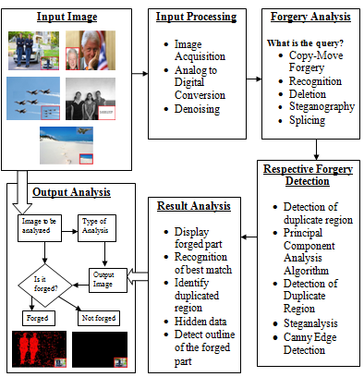

Fig9: Block diagram

**Input image:**

Input image is the image whose integrity is in question. It can either be in the form of hard copy or soft copy.

**Input processing:**

* **Image acquisition**: Images are obtained directly from devices like camera, scanner, etc or media, newspapers, magazines, hard copy of a photograph.
* **Analog to digital conversion:** To apply techniques of digital image processing, analog images must be converted into digital images.
* **Denoising:** Different filters like high-pass filter, low-pass filter, and median filter are used for denoising of the image. It reduces the effect of different noises present in the image like salt and pepper, gaussian etc.

**Forgery analysis:**

Asking the question, what is the query? Tells us about what is to be checked. The query tells us what type of forgery might be present. There are several types of forgeries possible like copy-move, splicing, steganography etc.

**Respective forgery detection:**

According to the type of forgery recognized in the previous stage, respective forgery detection algorithms are applied to the image. To detect a copy move forgery, duplicate region detection using Singular Value Decomposition (SVD) is performed. To detect steganography, Steganalysis using bit plane slicing is used. For recognizing objects or human faces with different inclinations, with physical modifications like use of accessories, or with modifications done by using image editing tools, Principal Component Analysis (PCA) is applied. To detect splicing, Canny edge detection is performed.

**Result analysis:**

After performing respective forgery detection as discussed in previous stage, the results are displayed accordingly. In case of copy-move, splicing, deletion of an object, the forged part, if any, is displayed. And in case of recognition using PCA, best match from the existing database is displayed.

**Output analysis:**

In this last stage, input image and the output displayed in the previous stage are compared to draw the final conclusion.

|  |  |  |  |
| --- | --- | --- | --- |
| **No.** | **Forgery** | **Detection Technique** | **Output** |
| 1. | Copy Move Forgery | Detection of Duplicate Region | Display forged part |
| 2. | Recognition | PCA Algorithm | Recognition of best match |
| 3. | Deletion of an object | Detection of Duplicate Region | Identify duplicated region |
| 4. | Steganography | Steganalysis | Hidden data |
| 5. | Splicing | Canny Edge Detection | Detect outline of the forged part |

Table1: Forgery Detection Methods

**Chapter 4: PROPOSED DESIGN**

* 1. **Flowcharts**

1. **Copy Move Forgery**

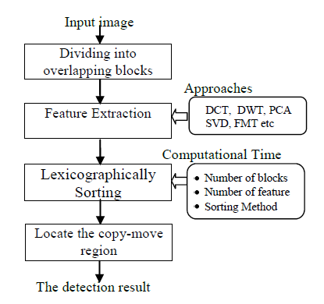

Fig10: Configuration of a block Copy-Move Digital Image Forgery Detection System

1. **Splicing**

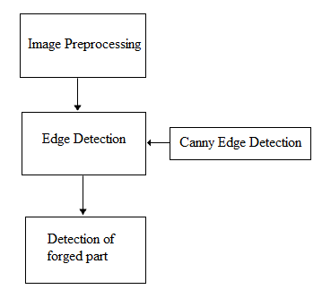

Fig11: Splicing Detection System

1. **Recognition**

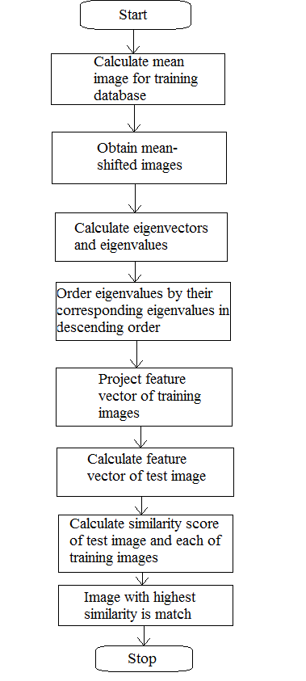

Fig12: Recognition using PCA.

1. **Deletion of an object**



Fig13: Deletion of an object Detection System

1. **Steganalysis**

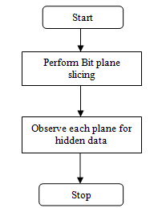

Fig14: Flowchart for Bit Plane Slicing

* 1. **Plan of work**

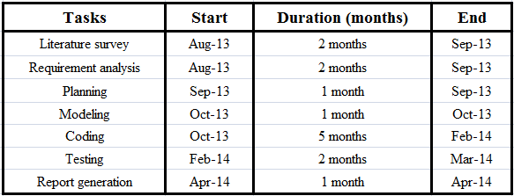

Table2: Plan of work

* 1. **Project Scheduling (Gantt Chart)**

Table3: Gantt chart

**Chapter 5: IMPLEMENTATION**

* 1. **Copy Move Forgery**

Copy-Move forgery is performed with the intention to add a copy of an object already existing in the image by copying it to the desired location. Since the copied segments come from the same image, the color palette, noise components, dynamic range and the other properties will be compatible with the rest of the image, thus it is very difficult for a human eye to detect. Sometimes, even it makes harder for technology to detect the forgery, if the image is retouched with the tools that are available.

There are many Copy-Move Forgery detection techniques available. However, in most other approaches the forged image is follow following algorithm:

1. Let N be the total number of pixels in a grayscale or color image.
2. Initialize the parameters:

* **b**: number of pixels per block ( pixels in dimension) - there are  
  such blocks.
* **Nn**: number of neighbouring rows to search in the lexicographically sorted matrix
* **Nf** : minimum frequency threshold
* **Nd**: minimum offset threshold

1. **Dividing the image into overlapping blocks** of size b.
2. **Feature Extraction:** Using SVD, compute singular values using A=USVT where U=AA*, V=A*A and S is the non-zero singular values of A are the square roots of the non-zero [eigenvalues](http://en.wikipedia.org/wiki/Eigenvalues) of both A*A and AA*. Different feature extraction methods can be used like PCA, DCT, DWT, [3], [4] etc.
3. Build a matrix whose rows are given by the singular values.
4. **Sort** the rows of the above **matrix in lexicographic order** to yield a matrix S. Let **Si** denote the rows of S, and let (**xi**, **yi**) denote the position of the block's image coordinates (top-left corner) that corresponds to **Si**.
5. **Locate similar blocks:**

* For every pair of rows **Si** and **Sj** from S such that |i - j| < Nn, place the pair of coordinates (**xi**, **yi**) and (**xj**, **yj**) onto a list.
* For all elements in this list, compute their offsets, defined as:

(**xi** - **xj** , **yi** - **yj** ) if **xi** - **xj** > 0

(**xj - xi** , **yi** - **yj**) if **xi** - **xj** < 0

(0, |**yi** - **yj**|) if **xi** = **xj**

* Discard all pairs of coordinates with an offset frequency less than **Nf**.
* Discard all pairs whose offset magnitude, , is less than **Nd**.
* From the remaining pairs of blocks build a duplication map by constructing a zero image of the same size as the original, and coloring all pixels in a duplicated region with a unique grayscale intensity value.



Fig15: **(a)** The original image **(b)** Forged image

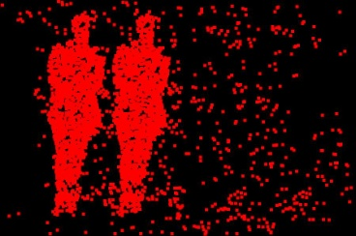

Fig15: **(c)** Output of copy-move forgery detection by SVD.

* 1. **Recognition**

PCA is one of the most important techniques in image recognition and feature extraction. Here we are using PCA for recognizing stamps and detecting whether stamp is forged one or not and as well for face recognition of criminals and any other object.

PCA of a matrix is given by:

* Denote column vectors xi ∈ Rn, i = 1, ..., N as the input data.
* The overall mean is: $\text{μ= }\frac{\text{1}}{\text{N}}\sum_{\text{i=1}}^{\text{N}}{\text{xi}}$
* The zero-meaned data is packed into a n×N matrix:

M = ( x1 - μ x2 - μ ….. xN - μ )

* The n x n covariance matrix is computed as :

C = MMT

* The principle components are the eigenvectors ej of the covariance matrix (i.e., Cjej=λjej), where the eigenvalue, λj is proportional to the variance of the original data along the jth eigenvector.)

Different version of PCA can be used to increase the speed and accuracy of the software.

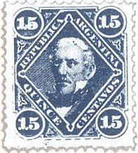

Fig16: **(a)** Forged stamp, **(b)** Original stamp. Comparing these two images after recognizing the original stamp we get to know the stamp is forged.

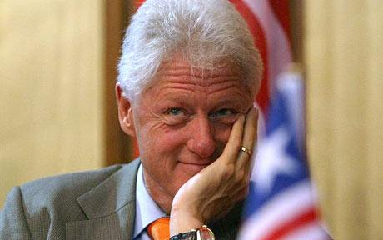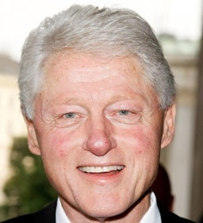

Fig17: **(a)** Image acquired, **(b)** Output image given by the recognition software. The software recognizing the person properly can be used for recognizing criminals in forensics.



Fig18: **(a)** Image acquired, **(b)** Output image recognized by the software. This software can also be used to recognize other object like flowers, animals, etc.

* 1. **Deletion of an Object**

Deletion of an object is performed with the intention to make an object “disappear” from the image by covering it with a small block copied from another part of the same image. Since the copied segments come from the same image, the color palette, noise components, dynamic range and the other properties will be compatible with the rest of the image, thus it is very difficult for a human eye to detect. Sometimes, even it makes harder for technology to detect the forgery, if the image is retouched with the tools that are available. Deletion of an object is same as Copy-Move Forgery since it uses the same concept for forgery.

There are many deletion of object detection techniques available. However, in most other approaches the forged image is follow following algorithm:

1. Let N be the total number of pixels in a grayscale or color image.
2. Initialize the parameters:

**b**: number of pixels per block ( pixels in dimension) - there are such blocks.

**Nn**: number of neighbouring rows to search in the lexicographically sorted matrix

**Nf**: minimum frequency threshold

**Nd**: minimum offset threshold

1. **Dividing the image into overlapping blocks** of size b.
2. **Feature Extraction:** Using SVD, compute singular values using A=USVT where U=AA*, V=A*A and S is the non-zero singular values of A are the square roots of the non-zero [eigenvalues](http://en.wikipedia.org/wiki/Eigenvalues) of both A*A and AA*. Different feature extraction methods can be used like PCA, DCT, DWT, [3], [4] etc.
3. Build a matrix whose rows are given by the singular values.
4. **Sort** the rows of the above **matrix in lexicographic order** to yield a matrix S. Let **Si** denote the rows of S, and let (**xi**, **yi**) denote the position of the block's image coordinates (top-left corner) that corresponds to **Si**.
5. **Locate similar blocks:**
   * For every pair of rows **Si** and **Sj** from S such that |i - j| < Nn, place the pair of coordinates (**xi**, **yi**) and (**xj**, **yj**) onto a list.
   * For all elements in this list, compute their offsets, defined as:

(**xi** - **xj** , **yi** - **yj** ) if **xi** - **xj** > 0

(**xj - xi** , **yi** - **yj**) if **xi** - **xj** < 0

(0, |**yi** - **yj**|) if **xi** = **xj**

* Discard all pairs of coordinates with an offset frequency less than **Nf**.
* Discard all pairs whose offset magnitude, , is less than **Nd**.
* From the remaining pairs of blocks build a duplication map by constructing a zero image of the same size as the original, and coloring all pixels in a duplicated region with a unique grayscale intensity value.

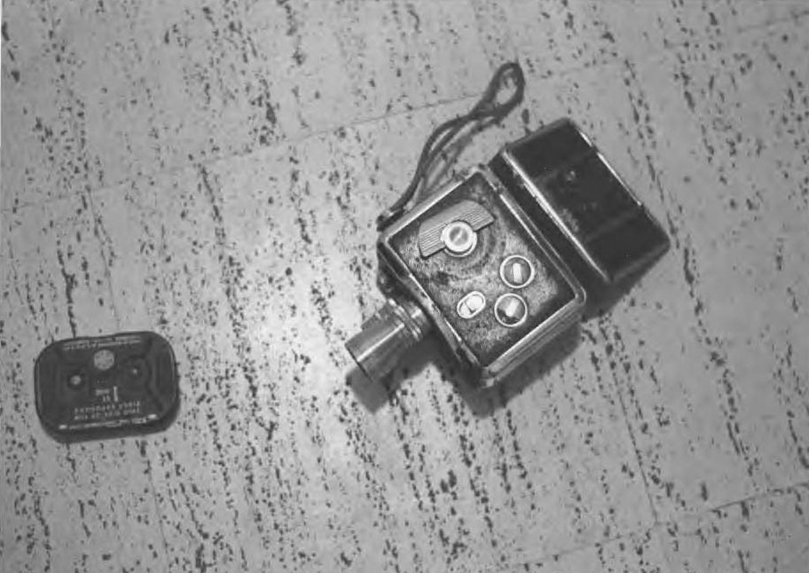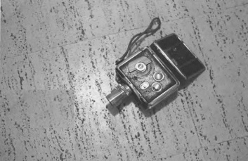

Fig19: **(a)** Original image. **(b)** Forged image

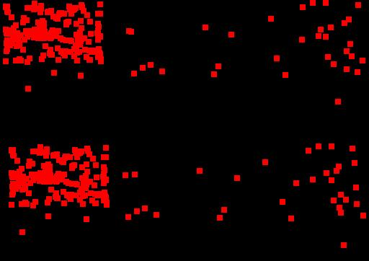

Fig19: **(c)** Output of deletion of an object detection by SVD.

* 1. **Splicing**

Splicing is copying and pasting areas from one or more images and pasting on to an image being forged. The image processing community formally refers to this type of image as an image “composition,” which is defined as the “digitally manipulated combination of at least two source images to produce an integrated result”.

General Splicing forgery detection methods are based on JPEG compression threshold which work for only JPEG image format. Today digital cameras support other image formats also. For this reason we propose novel methodology for photo forgery detection based on standard deviation based edge detection that detects the edges present in all directions.

The following steps explain the process of splicing forgery detection:

1. **Image Pre-processing:**

If the image data is not represented in HSV color space, it is converted to this color space by means of appropriate transformations. We only use the intensity data (v-channel of HSV) during further processing. Here V Channel represents the intensity image.

1. **Edge Detection:**

This step focuses the attention to areas where tampering may occur. We employ a simple method for converting the gray-level image into an edge image. Using Canny Edge detection we extract the edge image. Many other edge detection techniques can be used.

1. **Detection of Forged Region:**

The forged region is the one where there appears an edge even if it’s not visible in the acquired photo.

Canny Edge Detection algorithm:

The Canny operator was designed to be an optimal edge detector. In this situation, an "optimal" edge detector means:

* ***Good detection*** – the algorithm should mark as many real edges in the image as possible.
* ***Good localization*** – edges marked should be as close as possible to the edge in the real image.
* ***Minimal response*** – a given edge in the image should only be marked once, and where possible, image noise should not create false edges.

It works in a multi-stage process and it takes as input a gray scale image, and produces as output an image showing the positions of tracked intensity discontinuities.

Stages of Canny edge detector:

**Noise reduction:**

Because the Canny edge detector is susceptible to noise present in raw unprocessed image data, first of all, it convolutes the raw image with a Gaussian filter. The result is a slightly blurred version of the original.

The Gaussian smoothing in the Canny edge detector fulfils two purposes: first it can be used to suppress noise and second, it can be used to control the amount of detail that appears in the edge image.

**Finding intensity gradient:**

An edge in an image may point in a variety of directions, so the Canny algorithm uses four filters to detect horizontal, vertical and diagonal edges in the blurred image. The edge detection operator (Roberts, Prewitt, Sobel for example) returns a value for the first derivative in the horizontal direction (Gx) and the vertical direction (Gy). From this the edge gradient and direction can be determined:

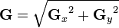

,

where G can be computed using the hypot function and atan2 is the arctangent function with two arguments. The edge direction angle is rounded to one of four angles representing vertical, horizontal and the two diagonals (0, 45, 90 and 135 degrees for example).

**Non-maximum suppression:**

This removes pixels that are not considered to be part of an edge. Hence, only thin lines (candidate edges) will remain.

**Hysteresis:**

Canny uses two thresholds (upper and lower):

1. If a pixel gradient is higher than the *upper* threshold, the pixel is accepted as an edge
2. If a pixel gradient value is below the *lower* threshold, then it is rejected.
3. If the pixel gradient is between the two thresholds, then it will be accepted only if it is connected to a pixel that is above the *upper* threshold.

This hysteresis helps to ensure that noisy edges are not broken up into multiple edge fragments. Canny recommended an *upper:* *lower* ratio between 2:1 and 3:1.

Guidelines:

The effect of the Canny operator is determined by three parameters --- the width of the Gaussian kernel used in the smoothing phase, and the upper and lower thresholds used by the tracker. Increasing the width of the Gaussian kernel reduces the detector's sensitivity to noise, at the expense of losing some of the finer detail in the image. The localization error in the detected edges also increases slightly as the Gaussian width is increased.

Usually, the upper tracking threshold can be set quite high and the lower threshold quite low for good results. Setting the lower threshold too high will cause noisy edges to break up. Setting the upper threshold too low increases the number of spurious and undesirable edge fragments appearing in the output.



Fig20: **(a)**The original image, **(b)** Forged image

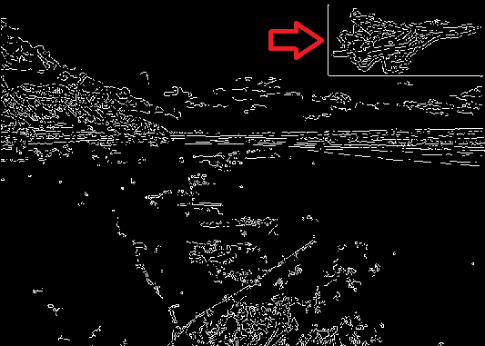

Fig20: **(c)** Output of splicing detection by Canny edge detector

* 1. **Double Quantization Effect**

When altering a JPEG image, typically it is loaded into photo–editing software (decompressed) and after manipulations is carried out; the image is re–saved (compressed again). The quantization matrix of the unaltered image is called as primary quantization matrix. The quantization matrix of the re–saved image is called as secondary quantization matrix. If the primary and secondary quantization matrix are not identical, then the re–saving (double compressing) operation brings into the image specific changes.

Certain quantization artifacts appear when applying JPEG compression more than once. If a JPEG file was opened, edited, then saved, certain compression artifacts will inevitably appear.



Fig21: **(a)** & **(b)** These two images look identical, although the second picture was opened in a graphic editor and then saved

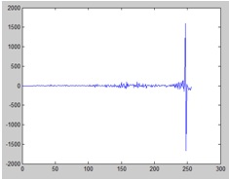

Fig21: **(c)** Difference in the histograms of images shown above.

 

Fig22: (a) Original image and (b) image is created by scaling the red rose as well as tilting by 180 degrees.

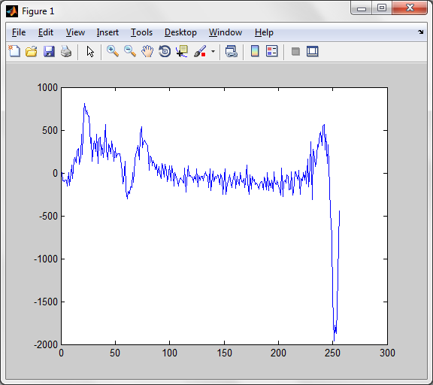

Fig22: (c) The difference in their histograms:

* 1. **Steganalysis**

Image Steganography is the process of secret communication where a piece of information (a secret message or an image, preferably encrypted) is encoded into the bits of an innocent looking cover image, in such a manner that the very existence of the secret information remains concealed without raising any suspicion in the minds of the viewers. Because of its inherent purpose of data hiding, Steganography requires the original and the Stego image to look alike. Steganography is more global in nature and offer vary little or no change to the image content in comparison to tampering which makes dramatic changes to the image content those are more local in nature.

A practical example of embedding in the 1st LSB and up to the 4th LSB is illustrated in figure below. Embedding in the 4th LSB generates more visual distortion to the cover image as the hidden information is seen as “non-natural”. Usually only 2 LSB are embedded as it does not create as much image distortion as 4 LSB embedding.

Bit Plane Slicing can be used to detect any anomalies in an image. If there are any anomalies, it means that the image is sending hidden data. In the figure below example bit plane slicing of the Stegno image will show 4 plane of 1st image MSBs and 4 planes of 2nd image MSBs bits.

Bit Plane Slicing is very easy method to detect any anomalies in images. In the example it will even give the hidden data but for some other image steganography techniques we might only see the anomalies actual hidden data might not be retrieved by bit plane slicing.



Fig23: The effect of altering the LSBs up to the 4th bit plane.

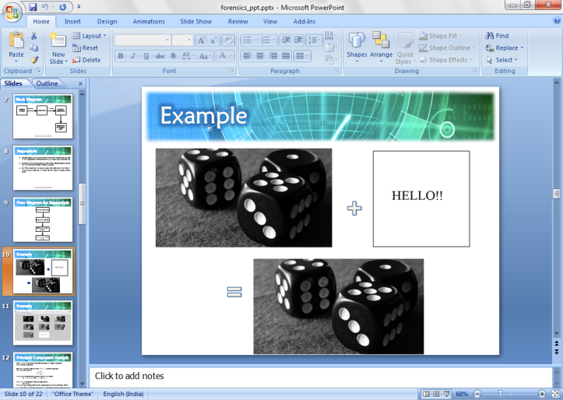

Fig24: Steganography

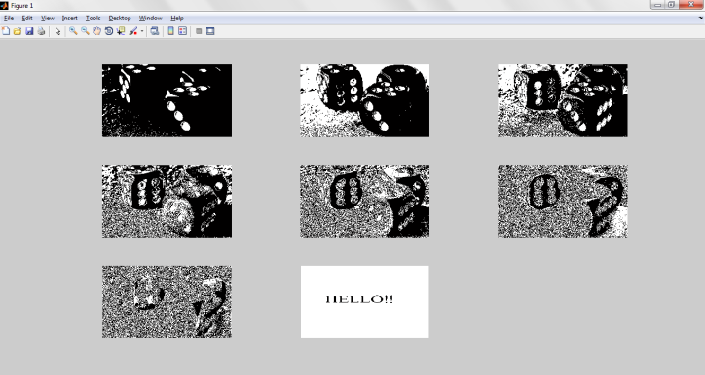

Fig25: Bit plane slicing (Steganalysis).

* 1. **Non-Consistent Image Quality**

JPEG is a lossy format. Every time the same image is opened and saved in the JPEG format, some apparent visual quality is lost and some artifacts appear. You can easily reproduce the issue by opening a JPEG file, saving it, closing, then opening and saving again. Repeat several times, and you’ll start noticing the difference; sooner if higher compression levels are specified.

Visual quality is not standardized, and varies greatly between the different JPEG compression engines. Different JPEG compression algorithms may produce vastly different files even when set to their highest-quality setting. As there is no uniform standard among the different JPEG implementations to justify resulting visual quality of a JPEG file, we had to settle on our own internal scale. This was inevitable to judge the quality of JPEG files processed by the many different engines on the same scale.

According to our internal scale, JPEG images coming out of the camera normally have apparent visual quality of roughly 80% (can be more or less, depending on camera settings and JPEG compression engine employed by the camera processor). As a result, we expect an unaltered image to fall approximately within that range. However, as JPEG is a lossy compression algorithm, every time a JPEG image is opened and saved as a JPEG file again, there is loss of apparent visual quality – even if the lowest compression / highest quality setting is used.

 

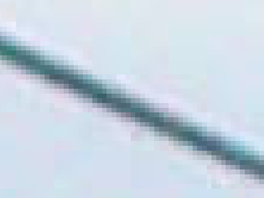 

Fig26: This is the same image, only the last three pictures are saved from the original with 90%, 70% and 50% quality respectively. The higher the level of compression is the more visible blocking artifacts become. JPEG is using blocks sized 8×8 pixels, and these blocks become more and more clearly visible when the image is re-saved.

**Chapter 6: RESULT ANALYSIS**

* 1. **Parameters**

Copy Move Forgery & Deletion of an Object

Following parameters are used:

* **b**: number of pixels per block ( $\sqrt{b} × \sqrt{b}$ pixels in dimension) - there are $N_{b}={(\sqrt{N}- \sqrt{b} +1)}^{2}$ such blocks.

**b** should be initialized properly, not to huge that the hole copied part is covered in one block.

* **Nn**: number of neighbouring rows to search in the lexicographically sorted matrix

**Nn** should be properly selected as if it is too less many false negatives values are found even though the amount of false positive decreases, and if it too huge then the number of false positive increases and the amount of false negative decreases.

* **Nf** : minimum frequency threshold

**Nf** is used to select blocks with same offset i.e. they are located at same distance. Since the offset of the copied part and original part will be the same, thus with the threshold value we can specify the offset frequency i.e. same offset occurring maximum number of times

* **Nd**: minimum offset threshold

**Nd** is used to calculate the distance between two pairs of blocks. **Nd** should be properly initialized as if it is less then too many block will pass the threshold and if too huge then none of might pass the threshold value.

* 1. **Graphs**

Effect of parameter **Nn** on output

 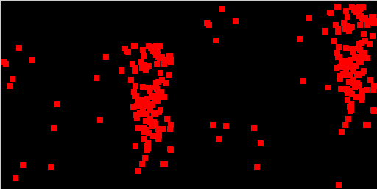

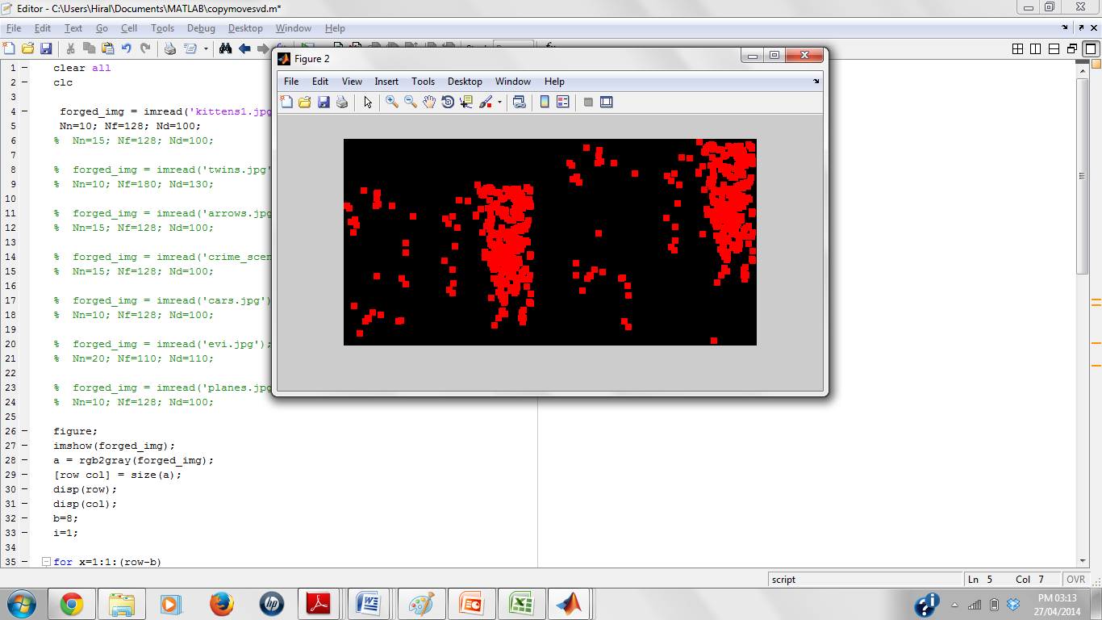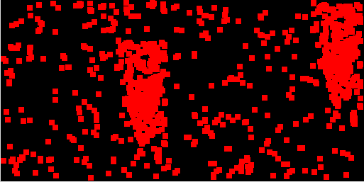

Fig27: (a) Forged image (b) Output with **Nn**=15 (c) Output with **Nn**=10 (d) Output with **Nn**=17

Fig28: Graph for the increase in selected pairs with increase in **Nn**

Effect of parameter **Nf** on output

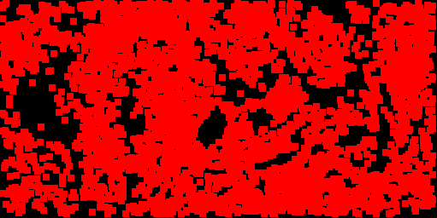

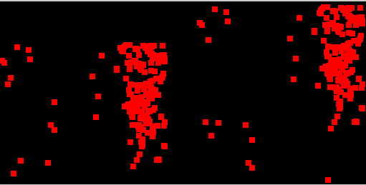

Fig29: (a) Forged image (b) Output with **Nf**=100 (c) Output with **Nf=**128 (d) Output with **Nf**=200

Fig30: Graph for the decrease in selected pairs with increase in **Nf**

Effect of parameter **Nd** on output

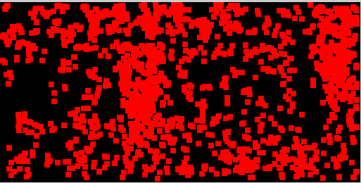



Fig31: (a) Forged image (b) Output with **Nd**=75 (c) Output with **Nd**=100 (d) Output with **Nd**=300

Fig32: Graph for the decrease in selected pairs with increase in **Nf**

* 1. **Output**

Copy Move Forgery:

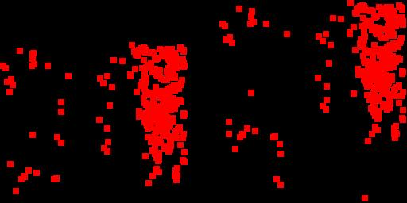

Fig33: (a) Forged Image, (b) Output image



Fig34: (a) Input Image (original), (b) Output image

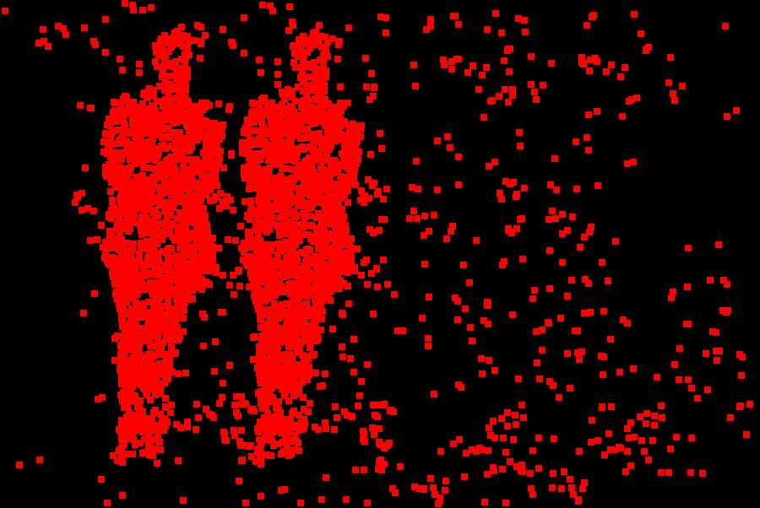

Fig35: (a) Forged Image, (b) Output Image

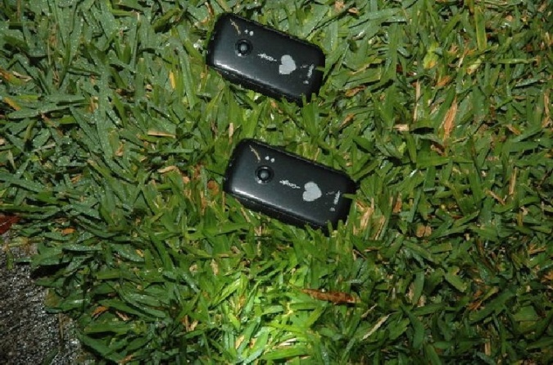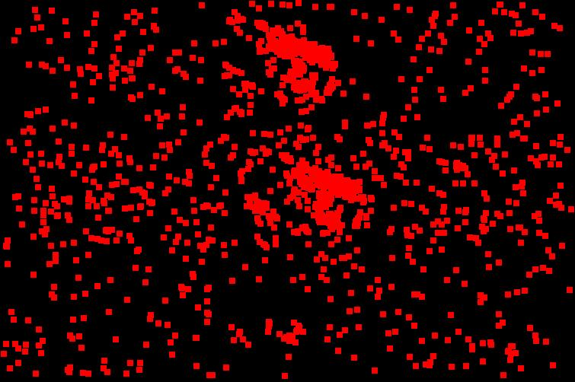

Fig36: (a) Forged Image, (b) Output image

Splicing:

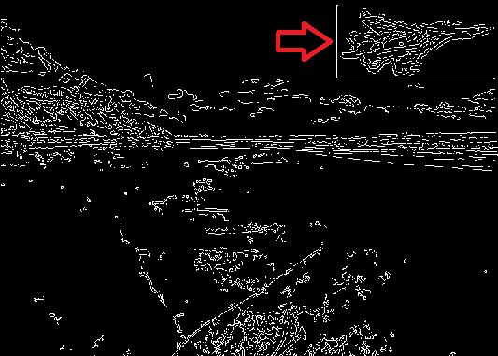

Fig37: (a) Forged Image, (b) Output image

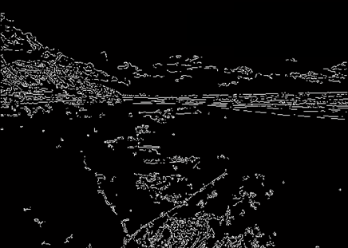

Fig38: (a) Input Image (original), (b) Output image



Fig39: (a) Forged Image, (b) Output image

Deletion of an object:

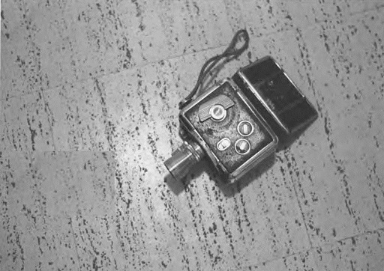 

Fig40: (a) Forged Image, (b) Output image

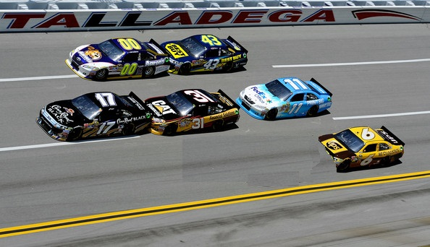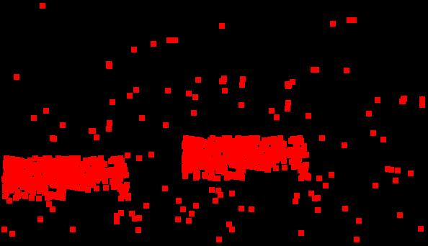

Fig41: (a) Forged Image, (b) Output image

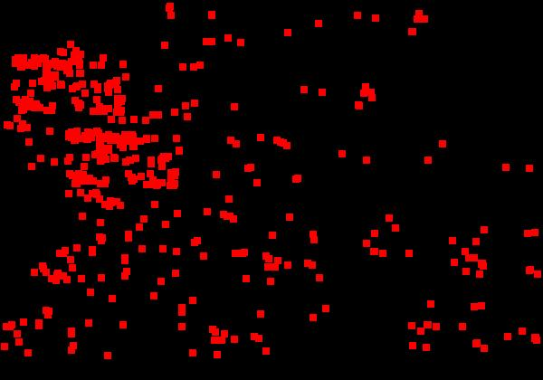

Fig42: (a) Forged Image, (b) Output image

Recognition:

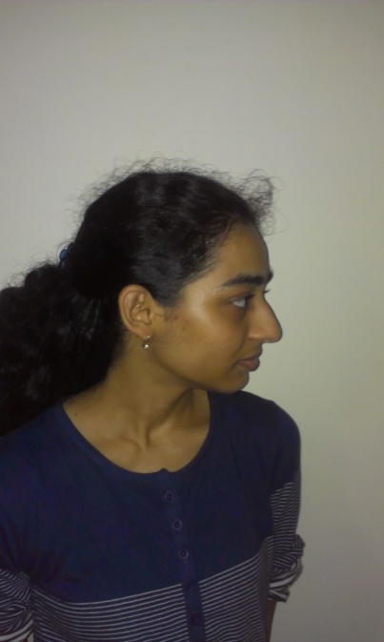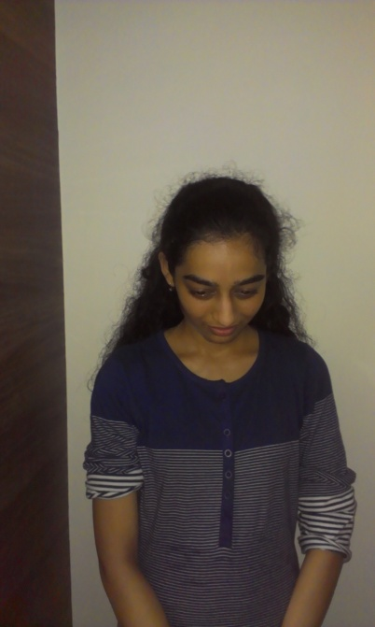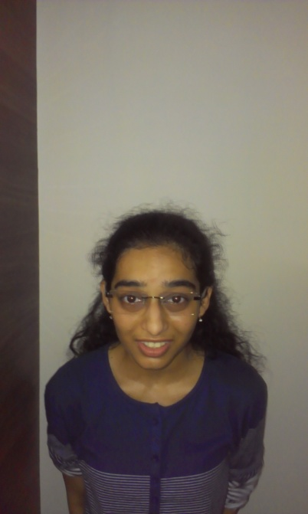



Fig43: (a), (b), (c), (d), (e) Input image, (f) Output image

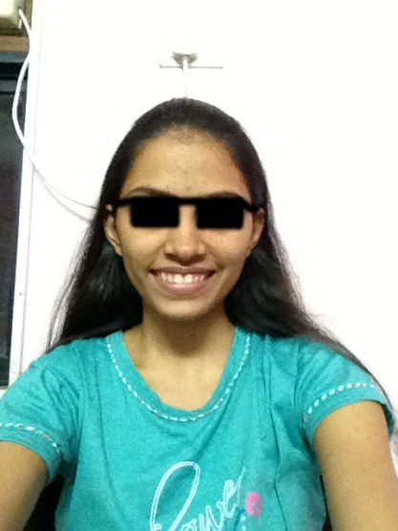

Fig44: (a), (b), (c), (d), (e) Input image, (f) Output image



Fig45: (a), (b) Input image, (c) Output image

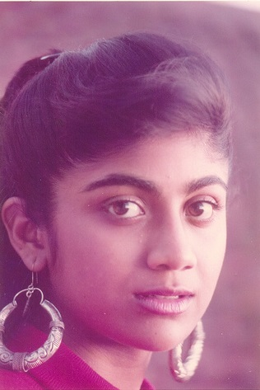

Fig46: (a), (b) Input image, (c) Output image

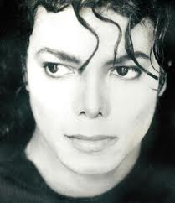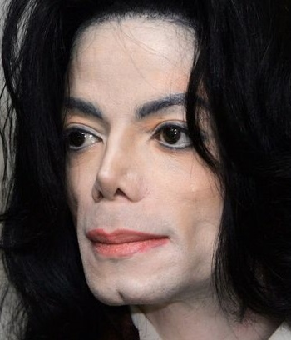 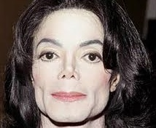

Fig47: (a), (b) Input image, (c) Output image

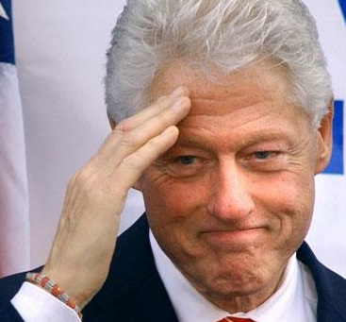

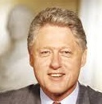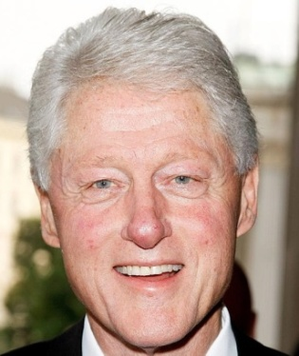

Fig48: (a), (b), (c) Input image, (d) Output image



Fig49: (a) Input image, (b) Output image

 

Fig50: (a) Input image, (b) Output image

 

Fig51: (a) Input image, (b) Output image

**Chapter 7: CONCLUSION**

* 1. **Limitations**

Most of the confidential forgery detection requires an Optical Laboratorywhich uses magnifiers, high-powered microscopes (micro and macro objectives), polarizer, complete spectral analyzers, including infrared, ultraviolet (short and long wave) and LASER fluorescence amplification technologies**.**

* 1. **Conclusion**

In this project we have analyzed different forgery techniques and implemented few algorithms for detecting some of them. Using MATLAB, we have reviewed and implemented few algorithms for detecting of some of the common types of forgeries like, copy move attack, splicing, deletion of an object, steganography etc. Moreover, we have also proposed a technique based on histogram of the image to detect double quantization effect in JPEG images. And all of the algorithms implemented work on the pixel level information to detect presence of particular type of image tampering.

**7.3 Future Scope**

There is a lot of research going on in this field and many other tampering detection techniques have been devised such as, detection based on examining the lighting environment, camera feature based detections, studying the statistical and geometric properties etc. Also, advancement in image forgeries necessitates detection techniques that make use of artificial intelligence, expert system, common sense reasoning, and machine learning technologies from the perspective of simulating human thought. In future, we can implement similar detection techniques for videos.

**References**

1. Alexey Kuznetsov, Yakov Severyukhin, Oleg Afonin, Yuri Gubanov, “Detecting Forged (Altered) Images”, Forensics Focus - Articles. http://articles.forensicfocus.com/2013/08/22/detecting-forged-altered-images/
2. G. R. Elwin J , Aditya T S , M. Shankar S,” Survey on Passive Methods of Image Tampering Detection”, International Conference on Communication and Computational Intelligence, 2010,pp .431-436.
3. Pradyumna Deshpande , Prashasti Kanikar, “Pixel Based Digital Image Forgery Detection Techniques”, International Journal of Engineering Research and Applications (IJERA), Vol. 2, Issue 3, May-Jun 2012, pp. 539-54.
4. Frank Y. Shih,Yuan Yuan, “A Comparison Study on Copy-Cover Image Forgery Detection”, The Open Artificial Intelligence Journal, 2010,pp. 49-54.
5. B.L.Shivakumar, Lt. Dr. S.Santhosh Baboo, “Detecting Copy-Move Forgery in Digital Images: A Survey and Analysis of Current Methods”, Global Journal of Computer Science and Technology, 2010, Vol. 10, Issue 7, pp. 61-65.
6. Alin C Popescu and Hany Farid, **“Exposing Digital Forgeries by Detecting Duplicated Image Regions”,** TR2004-515, Dartmouth College, Computer Science
7. S.Murali, G. B. Chittapur, Prabhakara H. S, B. S. Anami, “Comparison and Analysis of Photo Image Forgery Detection Techniques”, International Journal on Computational Sciences & Applications (IJCSA), 2012, pp.45-56
8. Canny edge Detector(Wikipedia) http://en.wikipedia.org/wiki/Canny_edge_detector
9. Canny edge Detector http://homepages.inf.ed.ac.uk/rbf/HIPR2/canny.htm
10. http://docs.opencv.org/doc/tutorials/imgproc/imgtrans/canny_detector/canny_detector.html Canny edge Detector
11. http://en.wikipedia.org/wiki/Singular_value_decomposition Singular Value Decomposition(SVD)
12. Zhang Ting , Wang Rang-ding, “Copy-Move Forgery Detection Based on SVD in Digital Image”, 2nd International Congress on Image and Signal Processing, 2009., pp 1-5.
13. Hany Farid, “Dgital Image Forensics”, pp. 68-69.
14. Nedevschi S, Peter I.R., Dobos I.A., Prodan C.,” An improved PCA type algorithm applied in face recognition”, [IEEE International Conference on](http://ieeexplore.ieee.org/xpl/mostRecentIssue.jsp?punumber=5598248) Intelligent Computer Communication and Processing (ICCP), 2010, pp. 259-265.
15. [Bozorgtabar B.](http://ieeexplore.ieee.org/search/searchresult.jsp?searchWithin=p_Authors:.QT.Bozorgtabar,%20B..QT.&searchWithin=p_Author_Ids:37860319300&newsearch=true),  [Noorian, F.](http://ieeexplore.ieee.org/search/searchresult.jsp?searchWithin=p_Authors:.QT.Noorian,%20F..QT.&searchWithin=p_Author_Ids:37546547700&newsearch=true), [Rezai Rad G.A.](http://ieeexplore.ieee.org/search/searchresult.jsp?searchWithin=p_Authors:.QT.Rezai%20Rad,%20G.A..QT.&searchWithin=p_Author_Ids:37300826600&newsearch=true), “Comparison of Different PCA based face recognition algorithms using genetic programming”, [5th International Symposium on](http://ieeexplore.ieee.org/xpl/mostRecentIssue.jsp?punumber=5724750) Telecommunications (IST), 2010,pp. 801-805.
16. Minati Mishra, Flt. Lt. Dr. M. C. Adhikary, “Digital Image Tamper Detection Techniques - A Comprehensive Study”, International Journal of Computer Science and Business Informatics, Vol. 2, No. 1. JUNE 2013, pp 1-12.
17. MATTHEW C. STAMM, MIN WU, K. J. RAY LIU, “Information Forensics: An Overview of the First Decade”, IEEE Access, Volume1, 2013, pp 167-200

**List of Figures**

Fig1: Splicing Example

Fig2: Retouching Example

Fig3: Copy Move Forgery Example

Fig4: Morphing Example

Fig5: Geometrical Transform Example

Fig6: Steganography Example

Fig7: Classification of forgery Detection Techniques

Fig8: Feature Extraction

Fig9: Block Diagram

Fig10: Copy Move Forgery Detection Flowchart

Fig11: Splicing Detection Flowchart

Fig12: Recognition using PCA Flowchart

Fig13: Deletion of an Object Detection Flowchart

Fig14: Steganalysis Flowchart

Fig15: Implementation of Copy Move Forgery Detection

Fig16: Implementation of Stamp Recognition

Fig17: Implementation of Face Recognition

Fig18: Implementation of Object Recognition

Fig19: Implementation of Deletion of an object Detection

Fig20: Implementation of Splicing Detection

Fig21: Double Quantization Effect Example 1

Fig22: Double Quantization Effect Example 2

Fig23: Block Diagram for Steganography

Fig24: Implementation of Steganography

Fig25: Steganalysis

Fig26: Non-Consistent Image Quality Example

Fig27: Effects of parameter **Nn**

Fig28: Graph of effects of parameter **Nn**

Fig29: Effects of parameter **Nf**

Fig30: Graph of effects of parameter **Nf**

Fig31: Effects of parameter **Nd**

Fig32: Graph of effects of parameter **Nd**

Fig33: Copy Move Forgery Detection Output 1

Fig34: Copy Move Forgery Detection Output 2

Fig35: Copy Move Forgery Detection Output 3

Fig36: Copy Move Forgery Detection Output 4

Fig37: Splicing Detection Output 1

Fig38: Splicing Detection Output 2

Fig39: Splicing Detection Output 3

Fig40: Deletion of an object Detection Output 1

Fig41: Deletion of an object Detection Output 2

Fig42: Deletion of an object Detection Output 3

Fig43: Face Recognition Output 1

Fig44: Face Recognition Output 2

Fig45: Face Recognition Output 3

Fig46: Face Recognition Output 4

Fig47: Face Recognition Output 5

Fig48: Face Recognition Output 6

Fig49: Object Recognition Output 1

Fig50: Stamp Recognition Output 1

Fig51: Stamp Recognition Output 2

**List of Tables**

Table1: Forgery Detection Methods

Table 2: Plan of work

Table3: Gantt chart

**Image Forgery Detection Techniques for Forensics Sciences**

**Sharmila Sengupta, Prajakta Shinde, Hiral Shah, Jaya Kukreja**

*Abstract*— With the ease of using image-processing tools, non-existing situations can be created and presented as evidence in a court of law. This diminishes the credibility of photographs as a definitive proof of events. The copy move forgery is one of the most common techniques of image tampering. In this paper we have discussed a copy move forgery detection system which uses duplicate region detection based on Singular Value Decomposition (SVD). Also for Splicing, another common technique of image tampering, we have proposed a detection system which is based on Canny edge detection. As face recognition is a very valuable aspect of criminal investigation, we have also discussed face recognition using PCA algorithm. Adding on, we have also discussed Double Quantization Effect in JPEG images and its detection, which implies that the JPEG image was re-saved after it was opened with a photo editor.

*Key Words*—Forgery Detection, Copy-Move Forgery, Double Quantization Effect, PCA, SVD, Splicing,

# INTRODUCTION

Digital Photo images are everywhere, on the covers of magazines, in newspapers, in courtrooms, and all over the Internet. We are exposed to them throughout the day and most of the time. Ease with which images can be manipulated; we need to be aware that seeing does not always imply believing. The use of digital photography has increased over the past few years, a trend which opens the door for new and creative ways to forge images. Now a day’s several software’s are available that are used to manipulate image so that the image is look like as original. Detecting these types of forgeries has become serious problem at present. To determine whether a digital image is original or doctored is a big challenge. To find the marks of tampering in a digital image is a challenging task.

For digital photographs to be used as evidence in law issues or to be circulated in mass media, it is inevitably needed to identify whether an image is authentic or not. The ease of creating faked digital images with a realistic quality makes us think twice before accepting an image as authentic. For the news photographs and the electronic check clearing systems, image authenticity becomes extremely critical. The verification of originality of images is required in variety of applications such as military, forensic, media, scientific, glamour, etc. Digital Image Forensics deals with the problem of certifying the authenticity of a picture, or its origin, without explicit a priori information, e.g. using watermarks. There are the three main branches in this research field: image source identification; discrimination of computer generated images; image forgery detection. In this paper we focused with the problem of detecting image forgeries.

Images have long been a part of forensic studies and law enforcement; for example images of criminals, images of crime scenes, biometric images, etc. Images play a vital role in the forensic laboratory, as images are used to document crime scene evidence. When these images are produced as evidences in courtrooms, integrity of images is very important. Images are used as authenticated proof for any crime and if these image does not remain genuine than it will create a problem. Most of the applications that use digital images are sensitive applications; like a judgment made in a courtroom based on an image produced as evidence, etc.

# FORGERY ANALYSIS IN FORENSICS

1. ***Questioned Documents:*** crime scene investigation, DNA testing, fiber analysis, fingerprint analysis, voice identification and narcotics analysis, handwriting analysis.
2. ***Art Forgery:*** It is the creating and selling of works of art which are falsely credited to other, usually more famous, artists.
3. ***Image Forgery [1],[2]:***
4. **Copy-Move Forgery: Images tampered by copying one area in an image and pasting it onto another area. It is called as Copy-Move Forgery or Cloning. This forgery is copying and pasting areas from one or more images and pasting on to an image being forged.**
5. **JPEG Format Analysis:** The JPEG Format Analysis algorithm makes use of information stored in the many technical meta-tags available in the beginning of each JPEG file. These tags contain information about quantization matrixes, Huffman code tables, and many other parameters as well as a miniature version (thumbnail) of the full image.

## Double Quantization Effect: Based on certain quantization artifacts appearing when applying JPEG compression more than once. If a JPEG file was opened, edited, then saved, certain compression artifacts will inevitably appear

## Error Level Analysis: It detects foreign objects injected into the original image by analyzing quantization tables of blocks of pixels across the image.

## Non-consistent Image Quality: JPEG is a lossy format. Every time the same image is opened and saved in the JPEG format, some apparent visual quality is lost and some artifacts appear.

## Mixed Images: Images generated by Splicing (combining two images) and Scaling and Tilting (copying an object and applying geometrical transform on it).

# COPY MOVE FORGERY

Copy-Move is a specific type of image manipulation, where a part of the image itself is copied and pasted into another part of the same image.

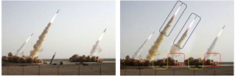

Fig 1. An example of copy-move forgery: (a) the original image with three missiles (b) The forged image with four missiles.[2]

Copy-Move forgery is performed with the intention to either make an object “disappear” from the image by covering it with a small block copied from another part of the same image or add a copy of an object already existing in the image by copying it to the desired location. Since the copied segments come from the same image, the color palette, noise components, dynamic range and the other properties will be compatible with the rest of the image, thus it is very difficult for a human eye to detect. Sometimes, even it makes harder for technology to detect the forgery, if the image is retouched with the tools that are available.

There are many Copy-Move Forgery detection techniques available. However, in most other approaches the forged image is follow following algorithm:

1. Let N be the total number of pixels in a grayscale or color image.
2. Initialize the parameters:

* **b**: number of pixels per block ( $\sqrt{b} × \sqrt{b}$ pixels in dimension) - there are $N_{b}={(\sqrt{N}- \sqrt{b} +1)}^{2}$ such blocks.
* **Nn**: number of neighboring rows to search in the lexicographically sorted matrix
* **Nf** : minimum frequency threshold
* **Nd**: minimum offset threshold

1. **Dividing the into overlapping blocks** of size b.
2. **Feature Extraction:** Using SVD, compute singular values using A=USVT where U=AA*, V=A*A and S is the non-zero singular values of A are the square roots of the non-zero [eigenvalues](http://en.wikipedia.org/wiki/Eigenvalues) of both A*A and AA*. Different feature extraction methods can be used like PCA, DCT, DWT, [3], [4] etc.
3. Build a matrix whose rows are given by the singular values.
4. **Sort** the rows of the above **matrix in lexicographic order** to yield a matrix S. Let **Si** denote the rows of S, and let (**xi**, **yi**) denote the position of the block's image coordinates (top-left corner) that corresponds to **Si**.
5. **Locate similar blocks:**

* For every pair of rows **Si** and **Sj** from S such that |i - j| < Nn, place the pair of coordinates (**xi**, **yi**) and (**xj**, **yj**) onto a list.
* For all elements in this list, compute their offsets, defined as:

(**xi** - **xj** , **yi** - **yj** ) if **xi** - **xj** > 0

(**xj - xi** , **yi** - **yj**) if **xi** - **xj** < 0

(0 , |**yi** - **yj**|) if **xi** = **xj**

* Discard all pairs of coordinates with an offset frequency less than **Nf** .
* Discard all pairs whose offset magnitude, , is less than **Nd**.
* From the remaining pairs of blocks build a duplication map by constructing a zero image of the same size as the original, and coloring all pixels in a duplicated region with a unique grayscale intensity value.



Fig 2. Configuration of a block Copy-Move Digital Image Forgery Detection System [4]

 

Fig 3. **(a)**The original image **(b)** Forged image



Fig 3. **(c)** Output of copy-move forgery detection by SVD.

 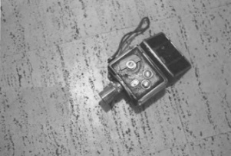

Fig 4. **(a)**The original image **(b)** Forged image



Fig 4. **(c)** Output of copy-move forgery detection by SVD.

# SPLICING

It is a method of tampering images by combining two sources to produce a new image which retains the majority of one image for detail. Fig.5 is an example of a spliced image.

 

Fig 5. (a) Source image (b) Target image



Fig 5. (c) Spliced image

Splicing is copying and pasting areas from one or more images and pasting on to an image being forged. The image processing community formally refers to this type of image as an image “composition,” which is defined as the “digitally manipulated combination of at least two source images to produce an integrated result”.

General Splicing forgery detection methods are based on JPEG compression threshold which work for only JPEG image format. Today digital cameras support other image formats also. For this reason we propose novel methodology for photo forgery detection based on standard deviation based edge detection that detects the edges present in all directions. The following steps explain the process of splicing forgery detection [5]:

1. **Image Pre-processing:**

If the image data is not represented in HSV color space, it is converted to this color space by means of appropriate transformations. We only use the intensity data (v-channel of HSV) during further processing. Here V Channel represents the intensity image.

1. **Edge Detection:**

This step focuses the attention to areas where tampering may occur. We employ a simple method for converting the gray-level image into an edge image. Using Canny Edge detection us extract the edge image. Many other edge detection techniques can be used.

1. **Detection of Forged Region:**

The forged region is the one where there appears an edge even if it’s not visible in the acquired photo.



Fig 6. **(a)** The original image **(b)** Forged image



Fig 6. **(c)** Output of splicing detection by Canny edge detector.

# Double Quantization Effect

When altering an JPEG image, typically it is loaded into a photo–editing software (decompressed) and after manipulations are carried out, the image is re–saved (compressed again). The quantization matrix of the unaltered image is called as primary quantization matrix. The quantization matrix of the re–saved image is called as secondary quantization matrix. If the primary and secondary quantization matrix are not identical, then the re–saving (double compressing) operation brings into the image specific changes.

Certain quantization artifacts appear when applying JPEG compression more than once. If a JPEG file was opened, edited, then saved, certain compression artifacts will inevitably appear [1].



Fig 7. **(a)** & **(b)** These two images look identical, although the second picture was opened in a graphic editor and then saved



Fig 7. **(c)** Difference in the histograms of images shown above.

# RECOGNITION

PCA is one of the most important techniques in image recognition and feature extraction. Here we are using PCA for recognizing stamps and detecting whether stamp is forged one or not and as well for face recognition of criminals and any other object.

PCA of a matrix is given by [6]:

* Denote column vectors xi ∈ Rn, i = 1, ..., N as the input data.
* The overall mean is: $\text{μ= }\frac{\text{1}}{\text{N}}\sum_{\text{i=1}}^{\text{N}}{\text{xi}}$
* The zero-meaned data is packed into a n×N matrix:

M = ( x1 - μ x2 - μ ….. xN - μ )

* The n x n covariance matrix is computed as :

C = MMT

* The principle components are the eigenvectors ej of the covariance matrix (i.e., Cjej=λjej),where the eigenvalue, λj is proportional to the variance of the original data along the jth eigenvector.)



Fig 8. Recognition using PCA.



Fig 9. **(a)**Forged stamp, **(b)** Original stamp. Comparing these two images after recognizing the original stamp we get to know the stamp is forged.

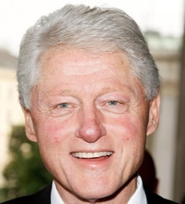

Fig 10. **(a)** Image acquired, **(b)** Output image given by the recognition software. The software recognizing the person properly can be used for recognizing criminals in forensics.



Fig 11. **(a)** Image acquired, **(b)** Output image recognized by the software. this software can also be used to recognize other object like flowers, animals, etc.

Different version of PCA can be used to increase the speed and accuracy of the software [7].

# CONCLUSION

Most of the confidential forgery detection requires an Optical Laboratorywhich uses magnifiers, high-powered microscopes (micro and macro objectives), polarizers, complete spectral analyzers, including infrared, ultraviolet (short and long wave) and LASER fluorescence amplification technologies**.** Using MATLAB, we have reviewed and implemented few algorithms for detection of some of the common types of forgeries. There is a lot of research going on in this field and many other tampering detection techniques have been devised such as, detection based on examining the lighting environment, camera feature based detections, studying the statistical and geometric properties etc. Moreover, advancement in image forgeries necessitates detection techniques that make use of artificial intelligent, expert system, common sense reasoning, and machine learning technologies from the perspective of simulating human thought.

**References**

1. Alexey Kuznetsov, Yakov Severyukhin, Oleg Afonin, Yuri Gubanov, “Detecting Forged (Altered) Images”, Forensics Focus - Articles.
2. G. R. Elwin J , Aditya T S , M. Shankar S,” Survey on Passive Methods of Image Tampering Detection”, International Conference on Communication and Computational Intelligence, 2010,pp .431-436.
3. Frank Y. Shih,Yuan Yuan, “A Comparison Study on Copy-Cover Image Forgery Detection”, The Open Artificial Intelligence Journal, 2010,pp. 49-54.
4. B.L.Shivakumar, Lt. Dr. S.Santhosh Baboo, “Detecting Copy-Move Forgery in Digital Images: A Survey and Analysis of Current Methods”, Global Journal of Computer Science and Technology, 2010, Vol. 10, Issue 7, pp. 61-65.
5. S.Murali, G. B. Chittapur, Prabhakara H. S, B. S. Anami, “Comparison and Analysis of Photo Image Forgery Detection Techniques”, International Journal on Computational Sciences & Applications (IJCSA), 2012, pp.45-56.
6. Hany Farid, “Dgital Image Forensics”, pp. 68-69.
7. Nedevschi S, Peter I.R. , Dobos I.-A. , Prodan C.,” An improved PCA type algorithm applied in face recognition”, IEEE International Conference on Intelligent Computer Communication and Processing (ICCP), 2010, pp. 259-265.
8. Bozorgtabar B.,  Noorian, F., Rezai Rad G.A., “Comparison of Different PCA based face recognition algorithms using genetic programming”, 5th International Symposium on Telecommunications (IST), 2010,pp. 801-805.
9. Pradyumna Deshpande , Prashasti Kanikar, “Pixel Based Digital Image Forgery Detection Techniques”, International Journal of Engineering Research and Applications (IJERA), Vol. 2, Issue 3, May-Jun 2012, pp. 539-54.

**Author’s Profile**

**Sharmila Sengupta,** Assistant professor, Department of Computer Engineering, V.E.S. Institute of Technology, University of Mumbai, Mumbai, India. Email: sharmilase@yahoo.com

M.E. Electronics and Telecommunication

Currently pursuing PHD in Mobile Networks.

Area of interest: Networking, Image processing.

**Hiral Shah,** Student, V.E.S. Institute of Technology, University of Mumbai, Mumbai, India. Email: [hiral.shah.06@gmail.com](mailto:hiral.shah.06@gmail.com)

Area of interest: Image processing, Database management systems

**Prajakta Shinde,** Student, V.E.S. Institute of Technology, University of Mumbai, Mumbai, India. Email: [prajaktashinde.7@gmail.com](mailto:prajaktashinde.7@gmail.com)

Area of interest: Image processing, Computer graphics

**Jaya Kukreja,** Student, V.E.S. Institute of Technology, University of Mumbai, Mumbai, India. Email: jayakukreja18@gmail.com

Area of interest: Image processing, Operating systems